**Daily Scrum or Standup Meeting**

Team name: Group 2

Scrum Master: Max Edwards

Date:____________February 14___________________

| **Team Member** | **What did you do since the last scrum?** | **What do you plan to do before the next scrum?** | **What obstacles do you have?** |
| --- | --- | --- | --- |
| Satchell Fausett | NA | NA | NA |
| Jared Hansen | React learning | Figure out how to integrate MUI component into React | Object Oriented Software, Cybersecurity |
| Chase Miller | Pushed up changes with models | Put server in the backend, do at least 1 story point | Calc 3 exam on Friday |
| Max Edwards | Reviewed pull requests and suggested feedback for backend | Finish login and navbar. Possibly start on new tasks | Not knowing everything about React |
|  |  |  |  |

# Burndown

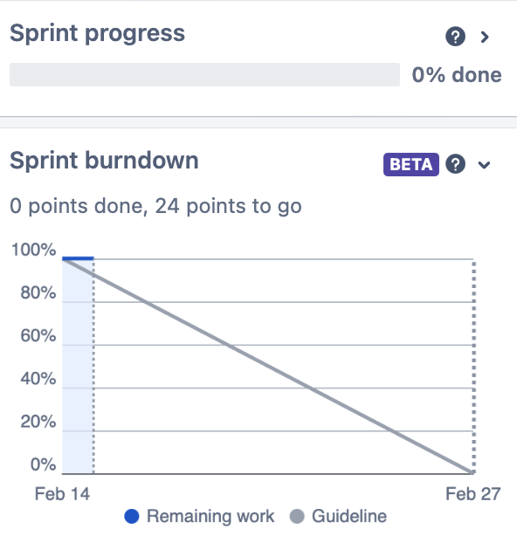

# Screenshot of you project board

